* 1. **User interfaces design**
     1. **Login**

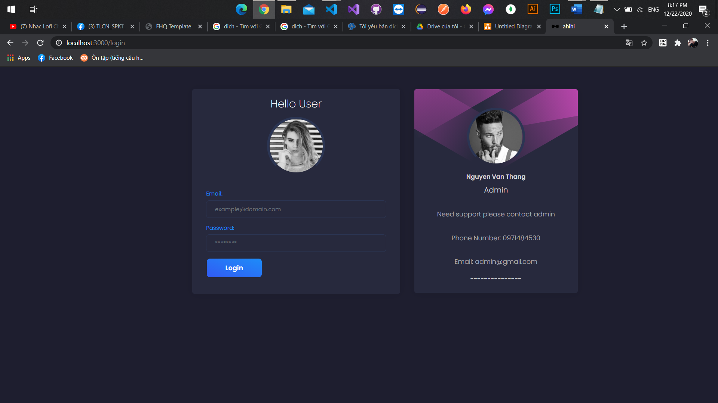

3

2

1

Figure 19 User interfaces login

|  |  |  |  |  |
| --- | --- | --- | --- | --- |
| No | Object name | Format | Action | Note |
| 1 | Text field’s username | Text field |  | A place to input username |
| 2 | Text field’s password | Text field |  | A place to input username |
| 3 | Button login | Button | Authenticate  to access the  website |  |

Table 21 Description for interfaces login

* + 1. **Upload document**

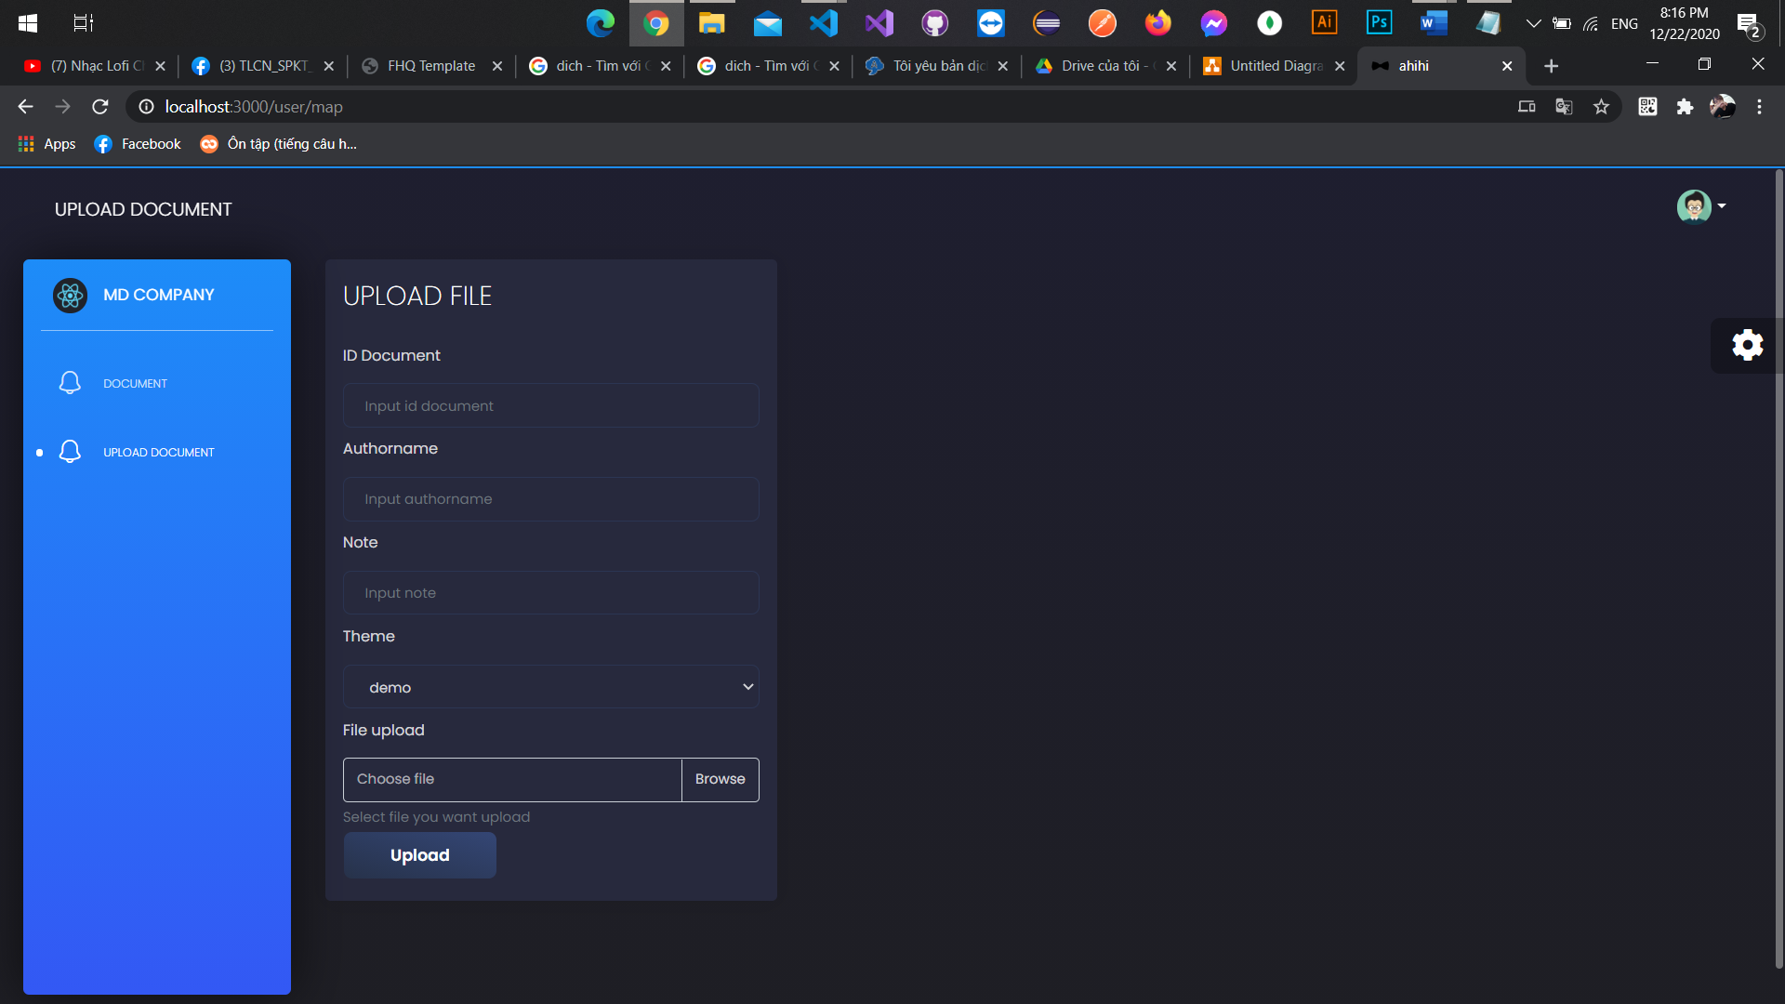

11

10

9

8

7

6

5

4

3

2

1

Figure 20 User interfaces upload document

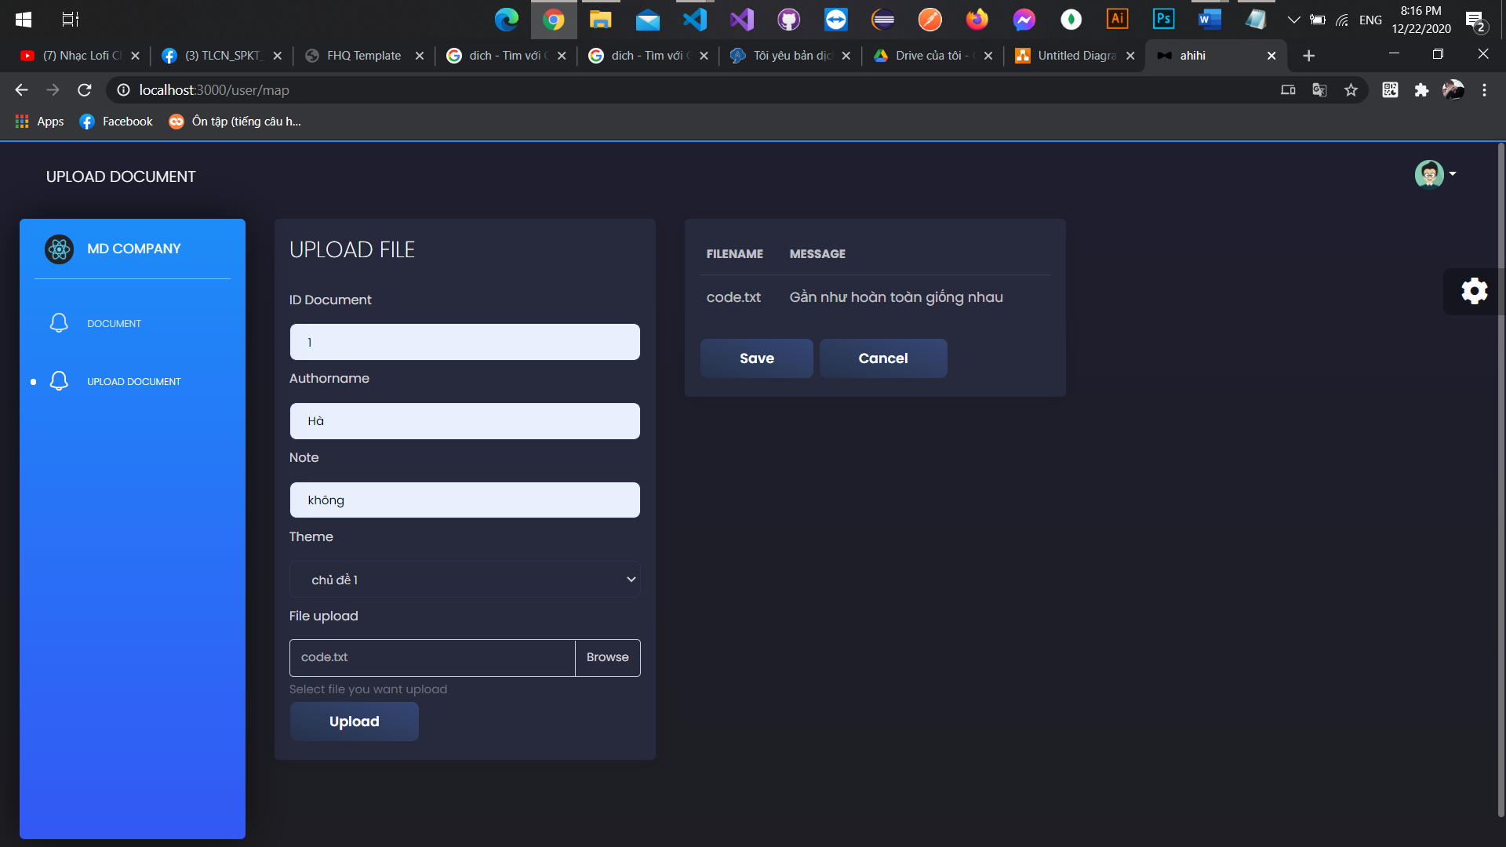

13

12

Figure 21 User interfaces upload duplicate document

|  |  |  |  |  |
| --- | --- | --- | --- | --- |
| No | Object name | Format | Action | Note |
| 1 | Company name | Text |  |  |
| 2 | Document | Router | Switch to the document page |  |
| 3 | Upload document | Router | Switch to the upload document page |  |
| 4 | Image user | Image | Logout user |  |
| 5 | Icon setting backgroud color | Icon | Change background color |  |
| 6 | Text field id document | Text field |  | A place to input id document |
| 7 | Text field authorname | Text field |  | A place to input id document |
| 8 | Text field note | Text field |  | A place to input id document |
| 9 | Text field theme | Text field |  | A place to input id document |
| 10 | Text field file upload | Text field |  | A place to input id document |
| 11 | Button upload | Button | Add new document |  |
| 12 | Button save | Button | Save duplicate documents |  |
| 13 | Button clear | Button | Cancel saving duplicate documents |  |

Table 22 Description for interfaces upload documents

* + 1. **Documents**

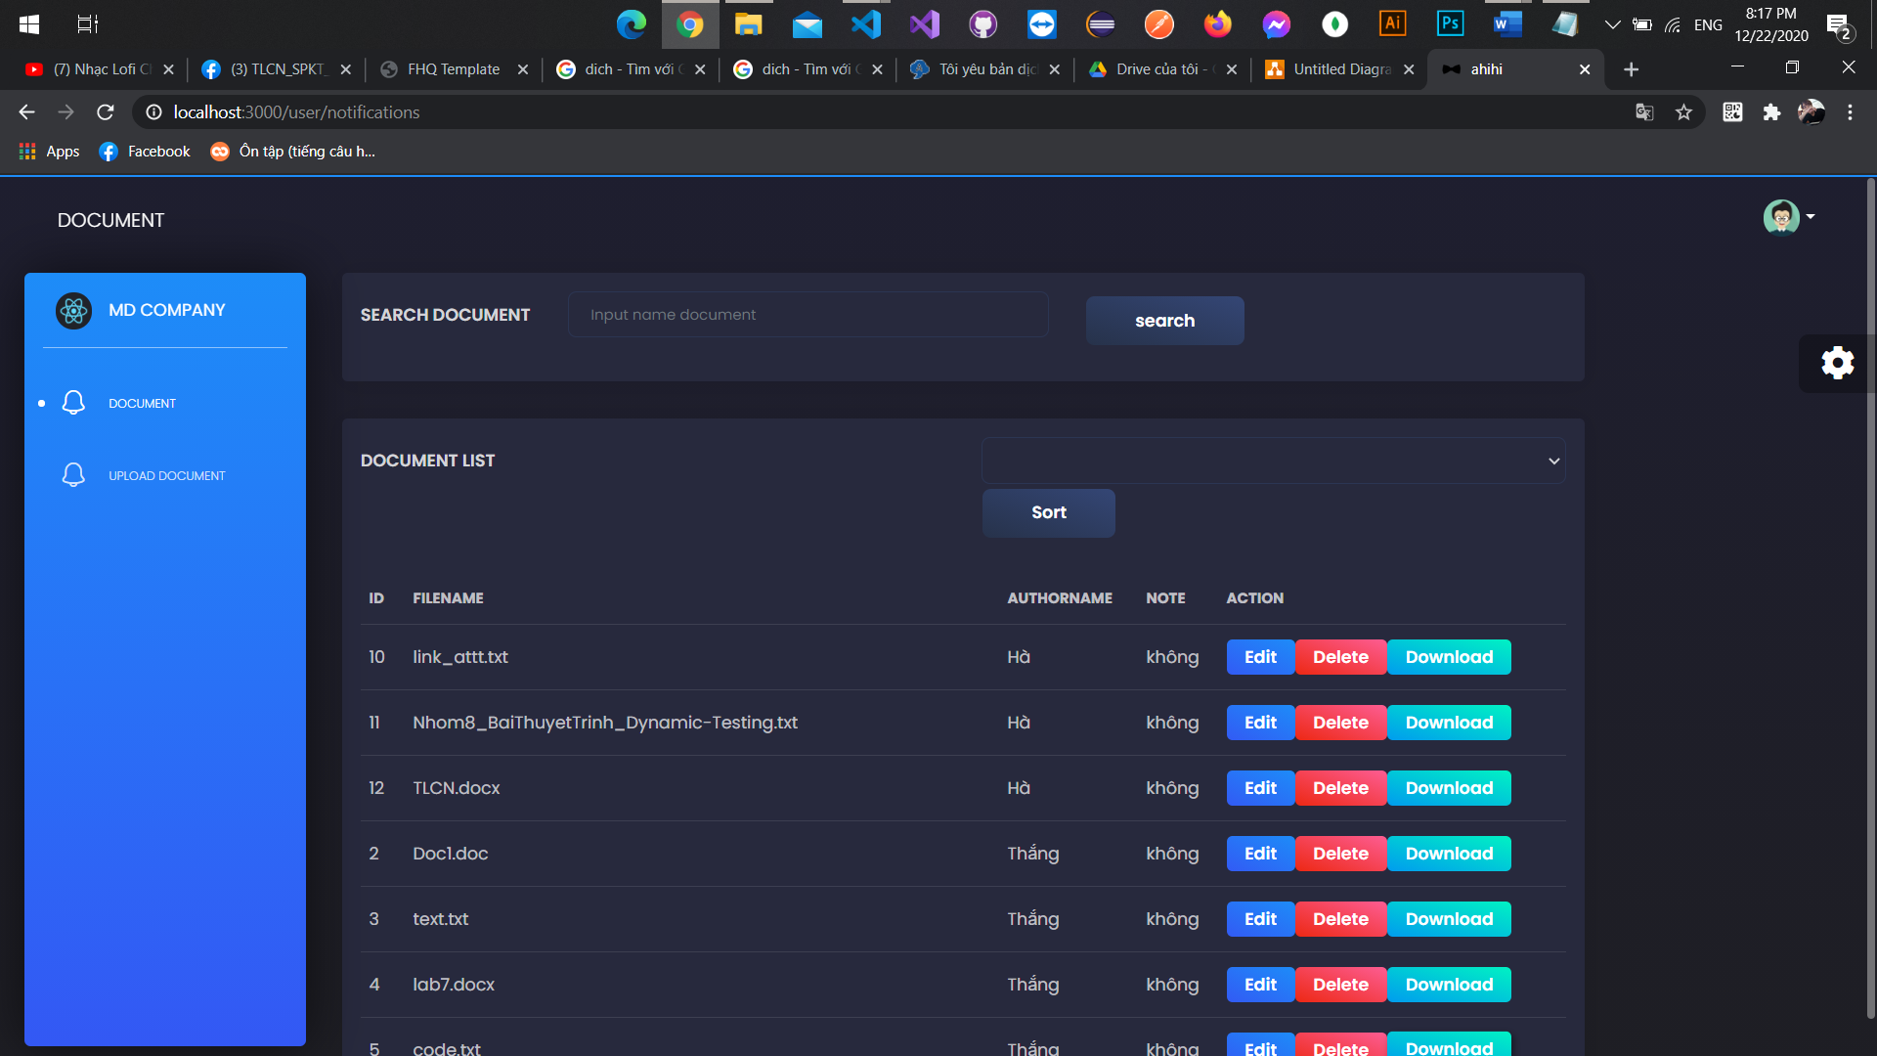

4

6

7

5

3

2

1

Figure 22 User interfaces documents

|  |  |  |  |  |
| --- | --- | --- | --- | --- |
| No | Object name | Format | Action | Note |
| 1 | Text field search | Text field |  | A place to input name document |
| 2 | Button search | Button | Search for documents by entered name |  |
| 3 | Select theme | Text Select |  | A place to input name theme |
| 4 | Button Sort | Button |  |  |
| 5 | Button Edit | Button | Edit selected document |  |
| 6 | Button Delete | Button | Delete selected document |  |
| 7 | Button Download | Button | Download selected document |  |

Table 23 Description for interfaces documents

* + 1. **Manage themes**

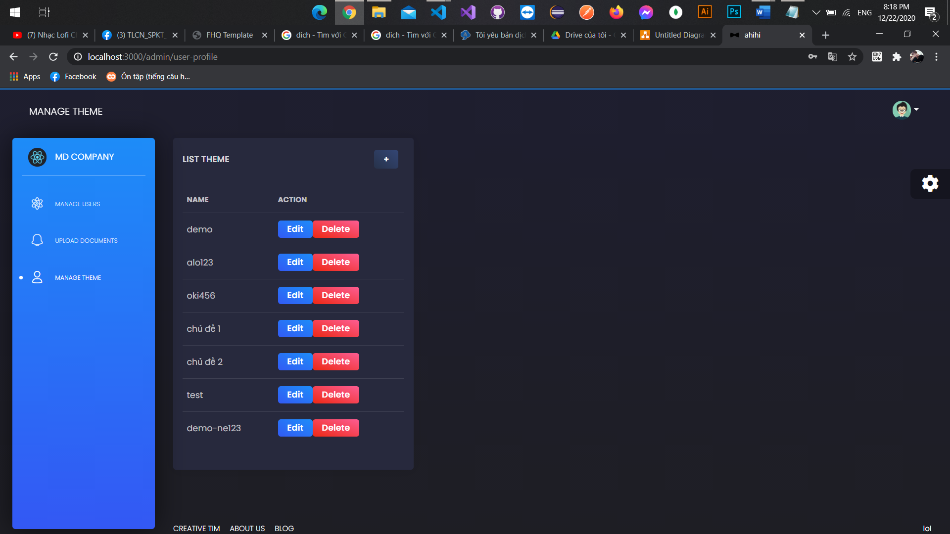

3

2

1

Figure 23 User interfaces list theme

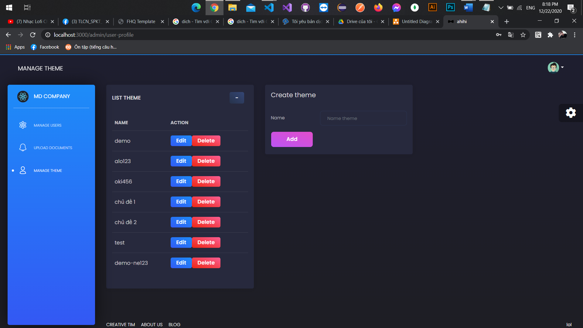

6

5

4

Figure 24 User interfaces create theme

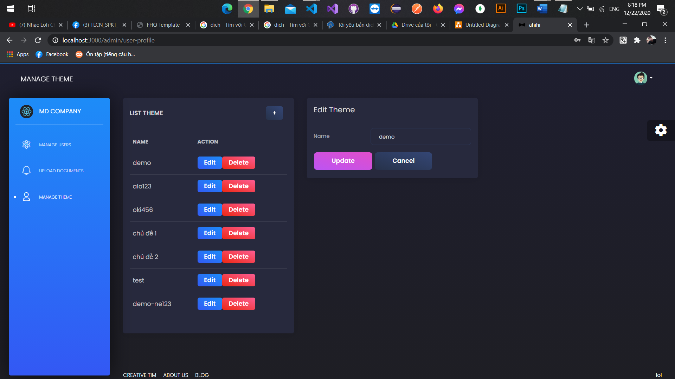

7

9

8

Figure 25 User interfaces edit theme

|  |  |  |  |  |
| --- | --- | --- | --- | --- |
| No | Object name | Format | Action | Note |
| 1 | Button + | Button | Display the theme form |  |
| 2 | Button edit | Button | Display the edit theme form |  |
| 3 | Button delete | Button | Delete selected theme |  |
| 4 | Text field name theme | Text field |  | A place to input name theme |
| 5 | Button Add | Button | Create a new theme |  |
| 6 | Button - | Button | Close the theme add form |  |
| 7 | Text field name theme | Text field |  | A place to input name theme |
| 8 | Button update | Button | Update selected theme with new information |  |
| 9 | Button cancel | Button | Cancel edit selected theme |  |

Table 24 Manage themes

* + 1. **Manage users**

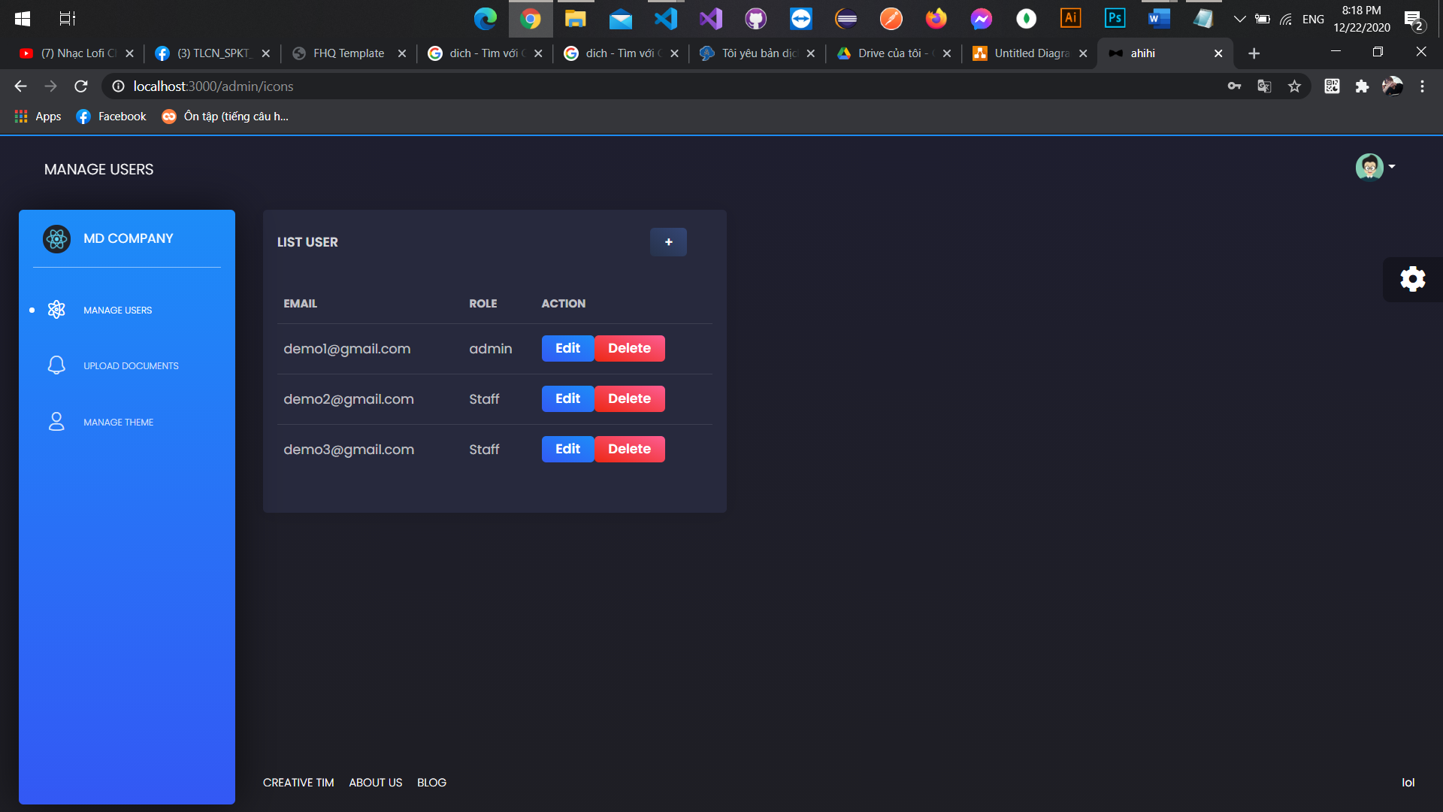

3

2

1

Figure 26 User interfaces list users

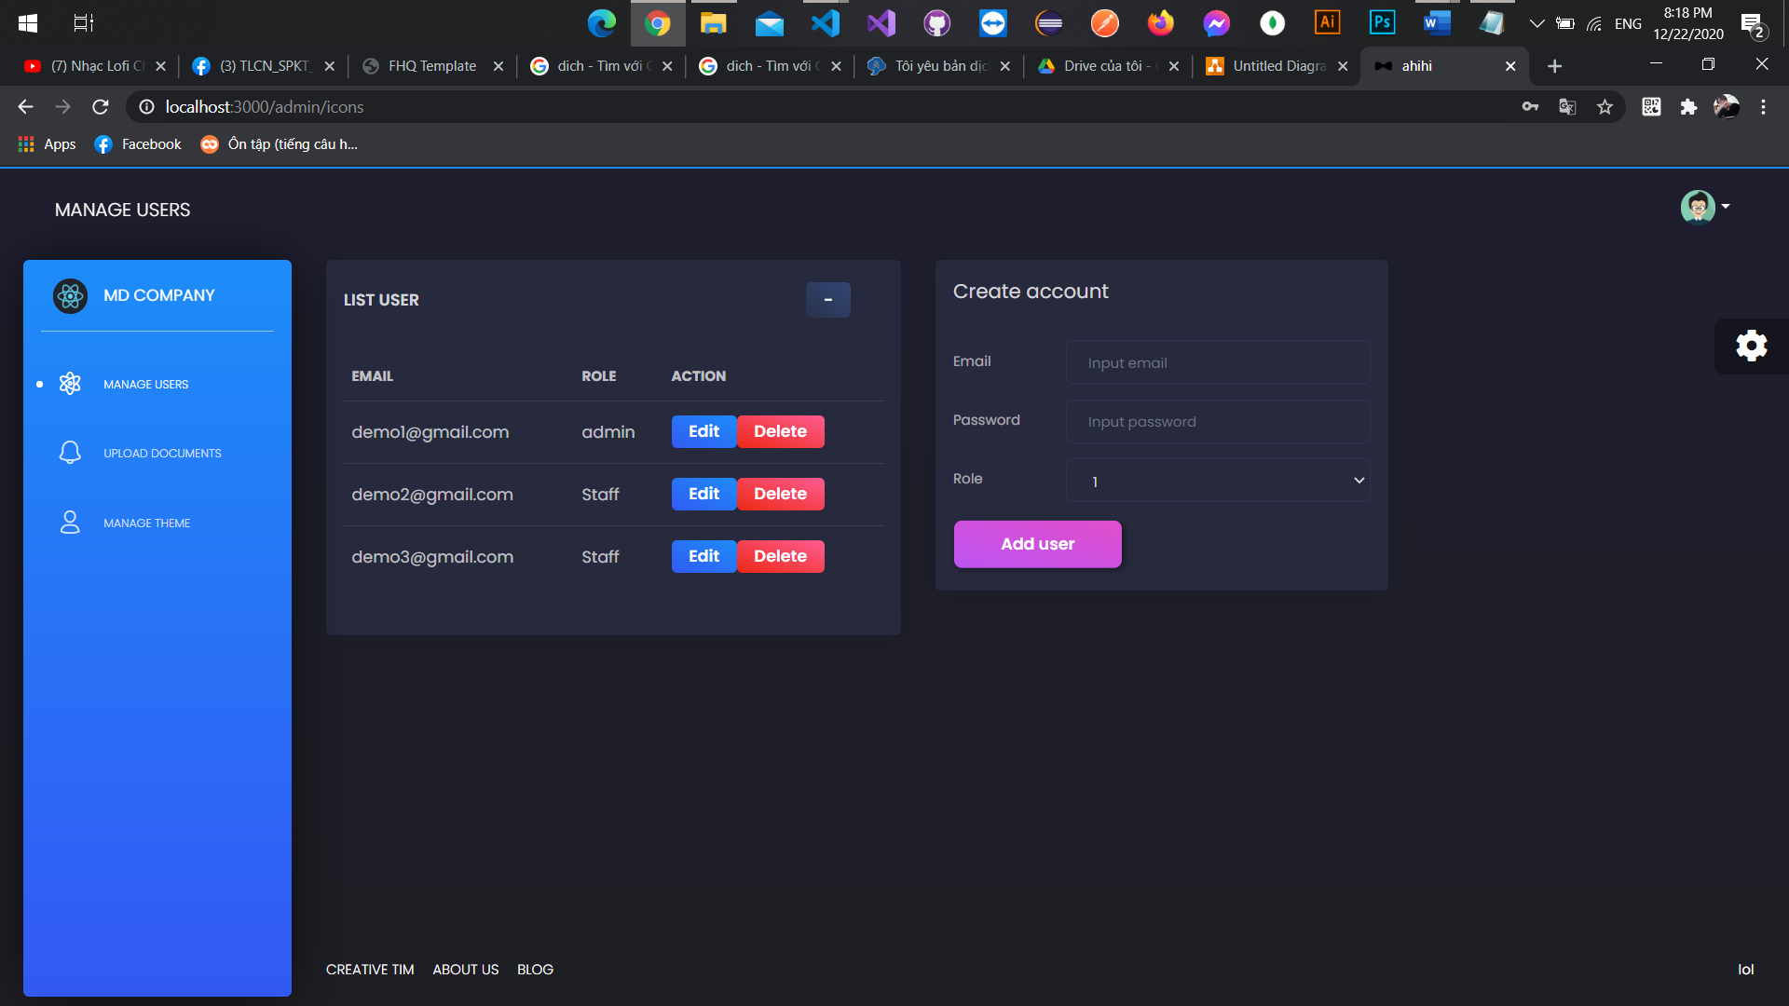

8

7

6

5

4

Figure 27 User interfaces create account

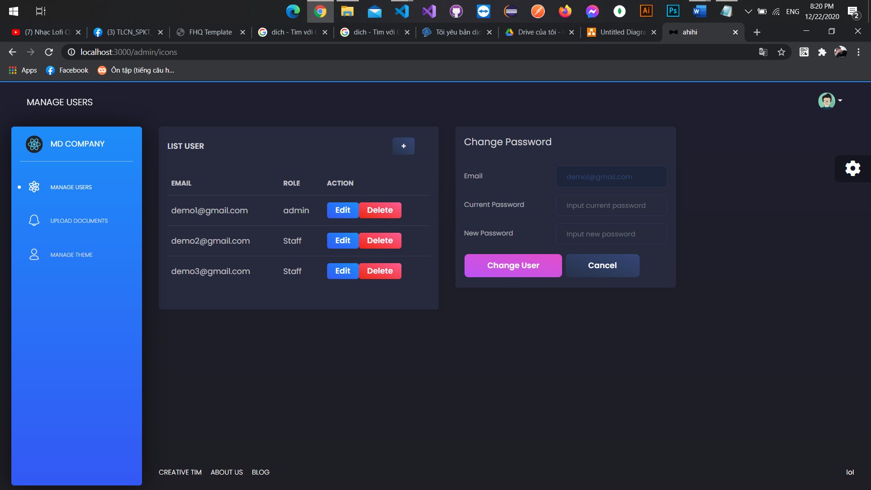

12

13

9

10

11

Figure 28 User interfaces change password

|  |  |  |  |  |
| --- | --- | --- | --- | --- |
| No | Object name | Format | Action | Note |
| 1 | Button “+” | Button | Display the create users form |  |
| 2 | Button edit | Button | Display the edit user form |  |
| 3 | Button delete | Button | Delete selected user |  |
| 4 | Text field email | Text field |  | A place to input email |
| 5 | Text field password | Text field |  | A place to input password |
| 6 | Text field role | Text field |  | A place to input role |
| 7 | Button adduser | Button | Create new user |  |
| 8 | Button “-” | Button | Close create user form |  |
| 9 | Text field email | Text field |  | Auto field |
| 10 | Text field current password | Text field |  | A place to input current password |
| 11 | Text field new password | Text field |  | A place to input new password |
| 12 | Button change user | Button | Update new password for selected user |  |
| 13 | Button cancel | Button | Cancel change password selected user |  |

Table 25 Description for interfaces manage users